CAB-00043 – Reachy-Orbita-Head-Supply Cable
Ver. | Date | Pub | Chk | Description
A1 | 14/02/2023 | EB | AC | Initial drawing.

Description
Delivering 12V from PCB Major Tom to DXL-Fan-Luos Module in order to supply the antenna’s motors. Please note that this cable goes through Orbita and thus requires to be made directly on Orbita.

Bill of Material
Item | Description | L (mm) | Qtté | Ref. Farnell / RS
Wire | 0,3 mm² | 350 | 2
Hirose DF11 Fem. Housing 8 ways | DF11-8DS-2C |  | 1 | 1688304 /
MicroFit Fem. Housing 2 ways | 43645-0200 |  | 1 | 3076015 /
Contacts for DF11 | DF11-2428SC |  | 2 | 1688393 /
Contacts for MicroFit | 46235-0001 |  | 2 | 2284551 /
Prolongateur | 22AWG - 16AWG |  | 2 | 587321 /

Assembly
Hirose DF11 Contacts are crimped with Hirose HT801/DF11-2428S(A) Tool
Molex MicroFit Contacts are crimped with the Molex 64016-0201 Tool.

Drawing
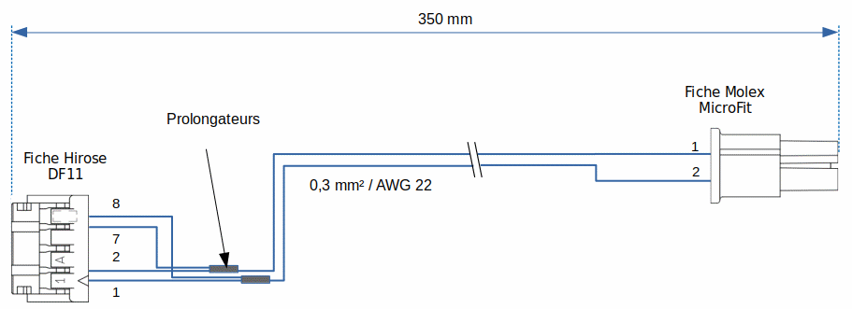

Nota
Again, note that this cable requires to be made directly on Orbita.

